Business Question and Visualization Report

Team ID | MCA
Project Name | Online Learning Engagement and Student Performance Analysis
Maximum Marks | 5 Marks

Visualization development refers to the process of creating graphical representations of data to facilitate understanding, analysis, and decision-making. The goal is to transform complex datasets into visual formats that are easy to interpret, enabling users to gain insights and make informed decisions. Visualization development involves selecting appropriate visual elements, designing layouts, and using interactive features to enhance the user experience. This process is commonly associated with data visualization tools and platforms, and it plays a crucial role in business intelligence, analytics, and reporting
Business Questions and Visualisation
In this activity, we will create and explore interactive data visualizations using two approaches: Q&A and the Manual method. We will use the Q&A feature to generate visualizations by asking questions in natural language and then create similar visualizations manually by selecting the appropriate fields, measures, and chart types.
1. What is the average student score across different regions?
Visualization: Bar chart showing average score by region
Screenshot:

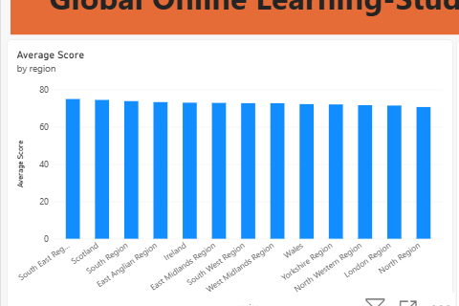

2. How are students distributed across different engagement levels?
Visualization: Pie chart showing total students by engagement level.
Screenshot:

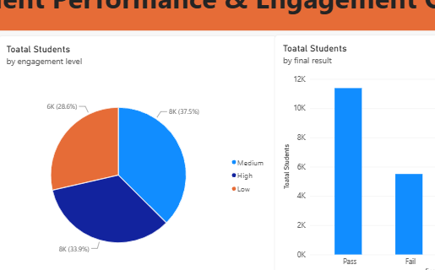
3. How are students distributed according to their final results?
Visualization: Column chart showing total students by final result.
Dashboard Name: Student Performance Dashboard
Purpose: To understand the distribution of students according to their final academic results.
Screenshot:

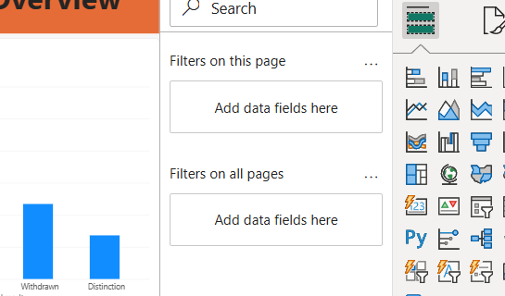

4. How does the average number of clicks vary by engagement level?
- Visualization: Column chart showing average total clicks by engagement level.
- Dashboard Name: Online Learning Engagement Dashboard
- Purpose: To analyze the relationship between student engagement levels and online learning activity.
Screenshot:

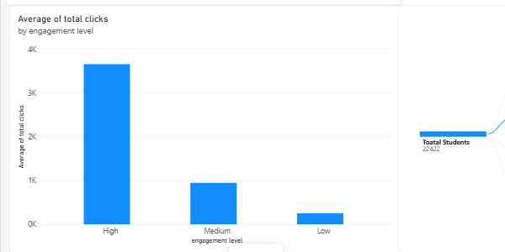

5. How does dropout rate vary according to the highest education level?
- Visualization: Column chart showing dropout rate by highest education level.
- Dashboard Name: Student Risk & Retention Dashboard
- Purpose: To identify differences in dropout rates among students with different education levels.
Screenshot:
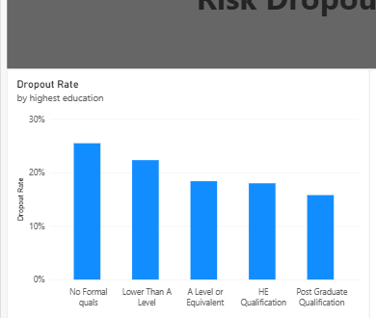
6. How are students distributed across different risk levels?
- Visualization: Pie chart showing total students by risk level.
- Dashboard Name: Student Risk Analysis Dashboard
- Purpose: To understand the proportion of students in different risk categories.
Screenshot:

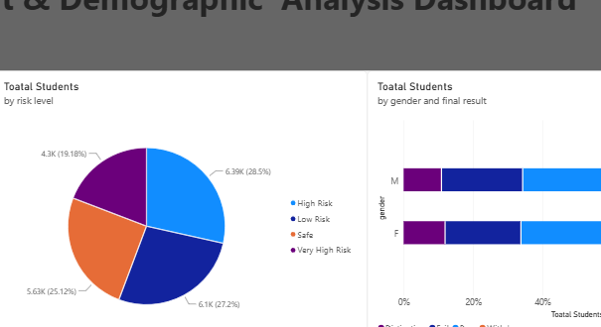

7. How does the pass rate vary according to the highest education level?
- Visualization: Column chart showing pass rate by highest education level.
- Dashboard Name: Student Performance Dashboard
- Purpose: To analyze pass-rate differences across students with different education levels.
Screenshot:
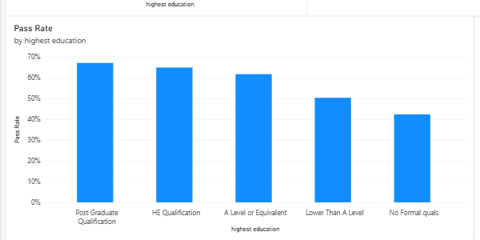
8.How do final results vary by gender?
- Visualization: Stacked bar chart showing total students by gender and final result.
- Dashboard Name: Student Performance Dashboard
- Purpose: To compare final academic results across different gender groups.
Screenshot:

